Zimbabwe

## Respect for rule of law (ROL) data

The data set shows the data on the respect of the rule of law for the country.

## # A tibble: 19 x 5  
## country iso3c date ruleOfLaw ruleOfLawCategory4   
## <chr> <chr> <dbl> <dbl> <chr>   
## 1 Zimbabwe ZWE 1996 -0.814 ROL moderately disrespected  
## 2 Zimbabwe ZWE 1998 -0.657 ROL moderately disrespected  
## 3 Zimbabwe ZWE 2000 -1.34 ROL highly disrespected   
## 4 Zimbabwe ZWE 2002 -1.59 ROL highly disrespected   
## 5 Zimbabwe ZWE 2003 -1.70 ROL highly disrespected   
## 6 Zimbabwe ZWE 2004 -1.80 ROL highly disrespected   
## 7 Zimbabwe ZWE 2005 -1.82 ROL highly disrespected   
## 8 Zimbabwe ZWE 2006 -1.74 ROL highly disrespected   
## 9 Zimbabwe ZWE 2007 -1.80 ROL highly disrespected   
## 10 Zimbabwe ZWE 2008 -1.78 ROL highly disrespected   
## 11 Zimbabwe ZWE 2009 -1.85 ROL highly disrespected   
## 12 Zimbabwe ZWE 2010 -1.82 ROL highly disrespected   
## 13 Zimbabwe ZWE 2011 -1.78 ROL highly disrespected   
## 14 Zimbabwe ZWE 2012 -1.63 ROL highly disrespected   
## 15 Zimbabwe ZWE 2013 -1.58 ROL highly disrespected   
## 16 Zimbabwe ZWE 2014 -1.43 ROL highly disrespected   
## 17 Zimbabwe ZWE 2015 -1.32 ROL highly disrespected   
## 18 Zimbabwe ZWE 2016 -1.37 ROL highly disrespected   
## 19 Zimbabwe ZWE 2017 -1.38 ROL highly disrespected

## Respect for rule of law (ROL) trend

The plot shows the trend of the respect for the rule of law for the country.

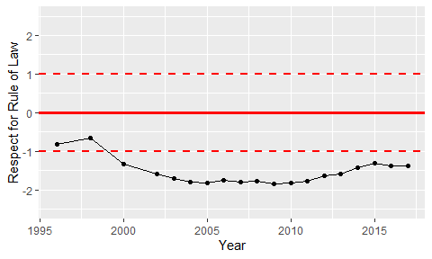

Trend of the Respect for the Rule of Law